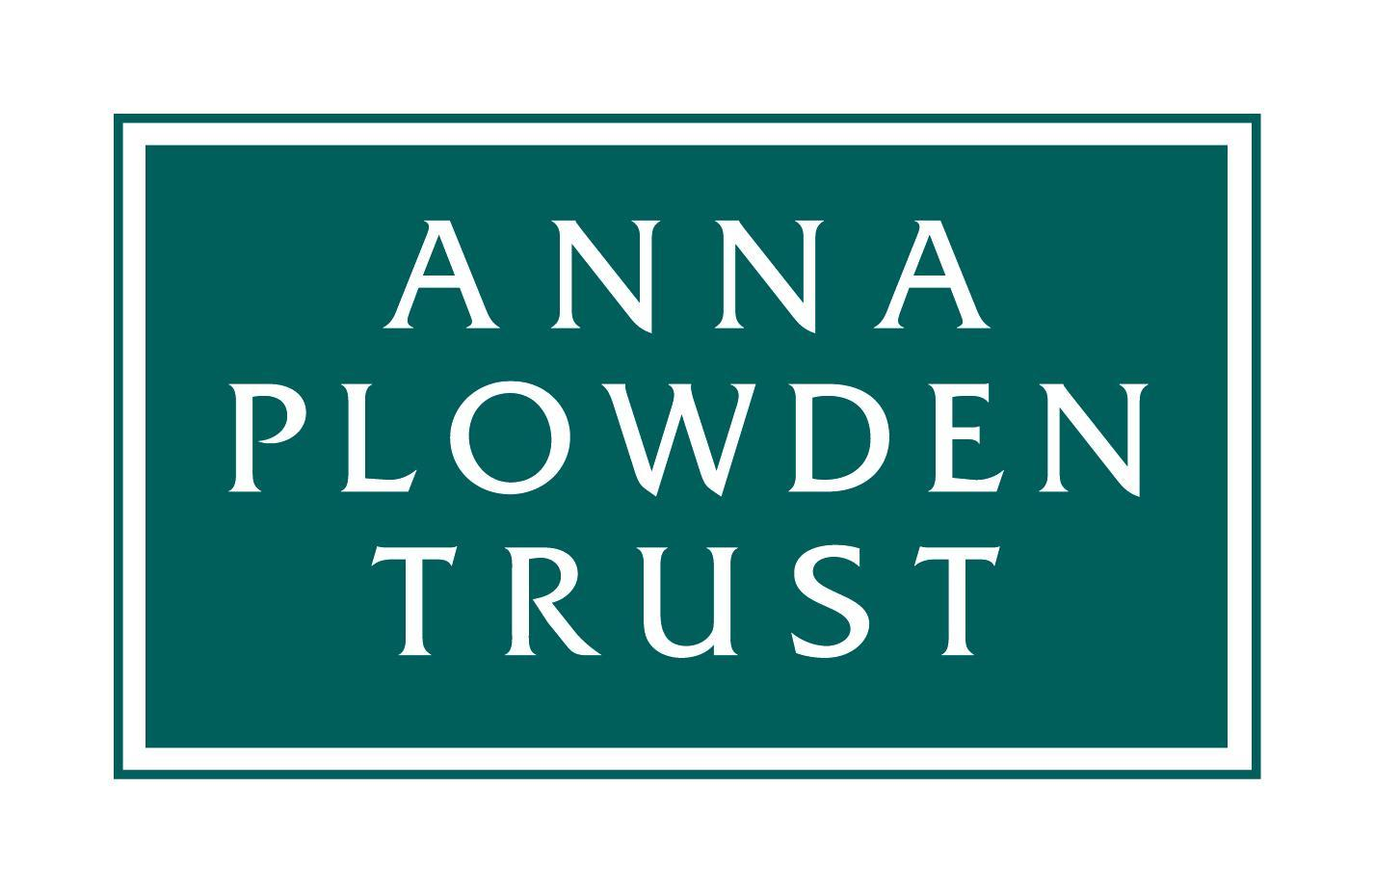
Reg. charity no. 1072236

PLOWDEN SCHOLARSHIP APPLICATION FORM

The deadline for applications is 3rd June 2024

The Anna Plowden Trust offers financial assistance towards the cost of attending a full- or part-time recognised conservation training programme. Applications will be considered from students who wish to embark on a career in conservation or existing conservators who need to broaden the base of their formal training by attending a course for at least one year. Every application will be considered regardless of whether an applicant has previously applied, whether successful or not.

We receive more applications than we can fund so when completing your form, please bear in mind that the Trustees:
- wish to support excellent applicants who can demonstrate their commitment to conservation
- seek to prevent financial reasons from being an obstacle to entering the conservation sector
- are committed to ensuring the Trust’s support reaches all underrepresented groups
- will normally give preference to applicants who intend to make their career in the UK
- will look favourably upon applicants who have made a significant effort to raise the funds elsewhere (i.e. from other grant-giving bodies)
- want their support to benefit the wider conservation sector as a whole.

Please read our terms and conditions of grants before completing this form.

Your full name:

Contact address:

Home address (if different from above):
Some of our funding is from trusts that like to support individuals from certain parts of the country so if you currently live in the town where you are studying but your family home is elsewhere please tell us where that is.

Mobile:

E-mail:

Website or Instagram account (if conservation-related):
Institution to be attended: | Which year will you be in in 2024/25?  e.g. year 1 of 2, year 2 of 3?
Level (e.g. Dip, PG Dip, MA) & Title of course: | Have you a firm offer of a place?

1. ABOUT YOU
EDUCATION
Please give a summary of your education or training after leaving school, indicating any formal qualifications:

WORK EXPERIENCE
Please give BRIEF details of any relevant previous work experience (e.g. internships, apprenticeships, volunteering):

MEMBERSHIPS
Please list the conservation or other heritage organisations of which you are a member (e.g. Icon):

2. FINANCIAL INFORMATION
SUMMARY OF COURSE COSTS:
Annual tuition fees | £
Living expenses | £
Travelling expenses | £
Other costs (give details - e.g. books, materials, tools) | £
Estimated total costs for the academic year | £
Grant you are requesting from the Anna Plowden Trust for 2024/25  Note that we are only able to support a proportion of the fees and are not normally able to give grants for living costs. However, if this disadvantages you then please make your case in Section 3. | £

SOURCES OF FUNDING:
To which other funding bodies have you applied? Applicants are encouraged to make a significant effort to raise the funds required. Give details below or list separately if necessary.

Funder | Amount applied for | Result  If the outcome is not yet known, when do you expect to hear?

Are you applying for a Student Loan, a Postgraduate Loan or equivalent? YES/NO
Please give details and if your answer is no, please explain why not.

Are there any personal circumstances that could prove a financial barrier to you undertaking this course?
Please give details. e.g. single parent, carer?

How would you fund your place on this course if you did not receive a grant from the Anna Plowden Trust?

3. CASE FOR SUPPORT
This section gives you the opportunity to put your case to the Trustees. They have many demands on their limited funds, so make clear – briefly and succinctly – why you deserve their support.
What do you hope to gain from the conservation programme? (Maximum 150 words)

FUTURE PLANS:
Do you intend to make your career in the UK? YES/NO
Are you eligible to do so? YES/NO/NOT AUTOMATICALLY*
* Please explain below

Professional plans once you have completed the course (Maximum 150 words)

Why do you feel you merit the support of the Anna Plowden Trust? (Maximum 500 words)

How did you first become aware of the Anna Plowden Trust?

4. DATA PROTECTION DECLARATION
You MUST complete this section before submitting your application.

I agree that the Anna Plowden Trust may retain relevant personal data (email, postal address, current job) and occasionally send me updates about the Trust’s work, the grants it offers and events it is organising. This agreement is given on the condition that the Trust does not share my data with any other organisation.

Yes No

Your signature: Date:

In signing this application, I confirm that the information that I have given is accurate and that I accept the terms and conditions, listed below, which would apply to any grant that may be awarded to me.

5. REFERENCES
References are an essential part of the scholarship selection process, and they will be considered when applications are assessed. Please see our separate ‘Guidance for Referees’ document.
You must submit two references with your application. These can be submitted together with this form or separately by email directly from your referees, if that is what they prefer.

First reference
The first reference should be from the course leader or a tutor of the conservation course you are planning to attend and should be in support of your application to the Anna Plowden Trust. A letter that simply confirms you have a place on the course is not sufficient. Course leaders and tutors are aware of this requirement.

Second reference
This might be from your employer (particularly if you have been working in a conservation related role), another tutor or supervisor, or from someone who knows you well and can comment on your suitability for a career in conservation and write in support of your application to the Anna Plowden Trust.

We receive very large numbers of applications and cannot chase missing references – if you fail to ensure that two references are supplied your application will not be considered.

NOW:
email your application form AND your references to: info@annaplowdentrust.org.uk

APPLICATIONS AND REFERENCES MUST BE RECEIVED BY 3rd June, 2024

Plowden Scholarships: Grant Conditions

1. The scholarship will be paid to your academic institution and not to you personally. The institution at which you study must email us an invoice at the beginning of the academic year (to info@annaplowdentrust.org.uk).

2. You must send us a report within two months of the end of the academic year (see further details below). In accepting the Scholarship you accept that we may quote, and use images, from your report on our website (www.annaplowdentrust.org.uk), social media and other publicity material without any further reference to you.

Plowden Scholars: Report Requirements

These should be up to 2,000 words long and contain a brief outline of the course and of your work during the year. Examples of rewarding experiences or of special objects conserved are important, together with analysis of how you found the course and what it has contributed in terms of preparing you for the coming year and/or a future career.

Your report should be accompanied by four or five digital images (in jpeg format, at least 2MB each) of you working on objects. The Anna Plowden Trust may use these images on its website and on social media so please ensure that you have permission to publish them and provide any attributions necessary. Please also provide a caption and credit line for each image. By supplying images you are agreeing that we may use these on our website or in our published annual report.

Your report should be submitted to info@annaplowdentrust.org.uk; if your images are large please send them to that email address using WeTransfer (https://www.wetransfer.com).

Please note: Failure to comply with these conditions will prejudice any future applications from you and may prejudice applications from other students at the same institution.

