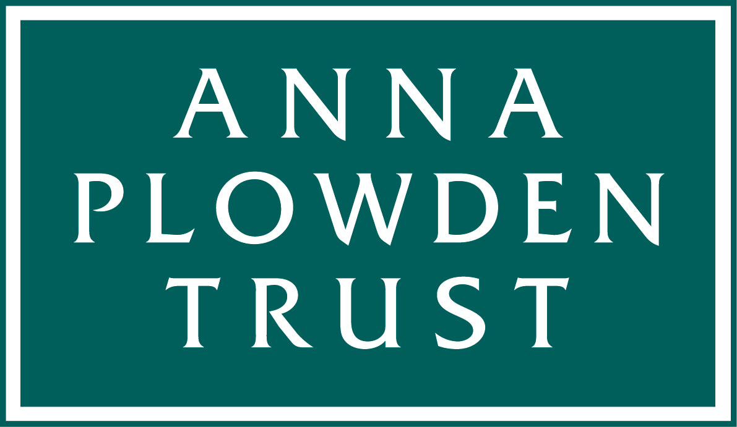
Plowden Scholarships: Grant conditions

Our grant conditions are simple:

1. The scholarship will be paid to your academic institution and not to your personally. The institution at which you study must email us an invoice at the beginning of the academic year (to info@annaplowdentrust.org.uk).

2. You must send us a report within two months of the end of the academic year (see further details below). In accepting the Scholarship you accept that we may quote from your report for use on our website (www.annaplowdentrust.org.uk) or other publicity material without any further reference to you.

Plowden Scholars: Report requirements

These should be up to 2,000 words long and contain a brief outline of the course and of your work during the year. Examples of rewarding experiences or of special objects conserved are important, together with analysis of how you found the course and what it has contributed in terms of preparing you for the coming year and/or a future career.

Your report should be accompanied by four or five digital images (in jpeg format) of you working on objects. The Anna Plowden Trust may use these images on its website and on social media so please ensure that you have permission to publish them and provide any attributions necessary. Please also provide a caption and credit line for each image. By supplying images you are agreeing that we may use these on our website or in our published annual report.

Your report should be submitted to info@annaplowdentrust.org.uk; if your images are large please send them to that email address using WeTransfer (https://www.wetransfer.com).

Please note: Failure to comply with these conditions will prejudice any future applications from you and may prejudice applications from other students at the same institution.

Data Protection

While your Scholarship grant is live we retain the personal details that you provided on your application form, so that we can ensure that you received your Scholarship and can be reminded if we do not receive a report/claim from you.

We like to keep in touch with our past Scholars and learn how their careers develop. At the end of the academic year in which we are supporting your studies we would like to continue to keep your email and postal address on file so that we can send you an annual report, updates on our grants and application deadlines and occasionally invite you to events we may organise. We only keep this data to enable us to send you news about the Anna Plowden Trust, we will not allow anyone else access to the data.

If you would prefer us not to keep your email and postal address on file please let us know (admin@annaplowdentrust.org.uk) and, once the academic year is complete and we have received your report, we will delete your personal data from our system.

