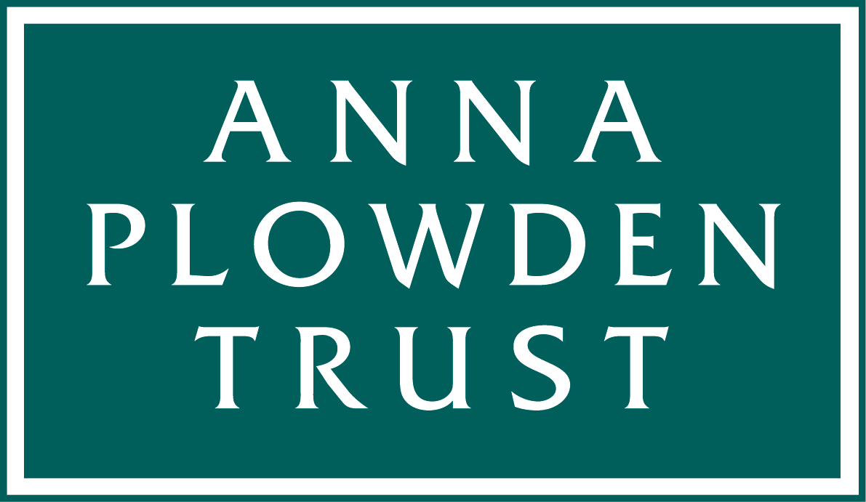
Anna Plowden/Clothworkers CPD Grants
Grant Conditions and Data Protection

Our CPD grants conditions are simple:

1. You must acknowledge our support
2. You must provide a report on the conference/course attended

Note that our grants are paid in arrears once we have received receipts as evidence of expenditure and your report.

Here are more details of these conditions. Please also read the important information about data protection below.

1. Acknowledgement

You should acknowledge the support of the Anna Plowden Trust and The Clothworkers’ Foundation where relevant (for example, in a conference presentation, paper or social media post). We can supply logos for your use.

If you post anything on Instagram please add @annaplowdentrust and Facebook is trustannaplowden.

2. Report and grant claim

1. You must send a report within one month of the course or conference you attended with The Anna Plowden Trust/Clothworkers’ Foundation’s assistance.

Your report should be about 600-700 words long and describe what you hoped to get out of the course/conference, give a brief analysis of the content of the course and an evaluation of the benefits to you/your institution of your attendance – for example how you disseminated the knowledge gained. You should also include three or four jpegs of you at the event. Please also provide a caption and credit line for each image. By supplying images you are agreeing that the Trust may use these on its website, social media or in its published annual report.

Note We may quote from your report on our website (http://annaplowdentrust.org.uk), social media or other publicity material without any further reference to you.

Your report and grant claim should be submitted by email to us at:
info@annaplowdentrust.org.uk
if your images are large please send them to that email address using WeTransfer (https://www.wetransfer.com).

Note:
Failure to comply with these conditions will prejudice any future applications from you and may prejudice applications from others at the same institution

Data Protection

While your grant is live we retain the personal details that you provided on your application form, so that we can ensure that you receive payment of your grant and can be reminded if we do not receive a report/claim from you.

Once your CPD grant has been claimed and ‘closed’ we would like to continue to keep your email and postal address on file so that we can send you an annual report, updates on our grants and application deadlines and occasionally invite you to events we may organise.

We only keep this data to enable us to send you news about the Anna Plowden Trust, we will not allow anyone else access to the data.

If you would prefer us not to keep your email and postal address on file please let us know (admin@annaplowdentrust.org.uk) and, once your CPD grant has been claimed, we will delete all your personal data from our system.

