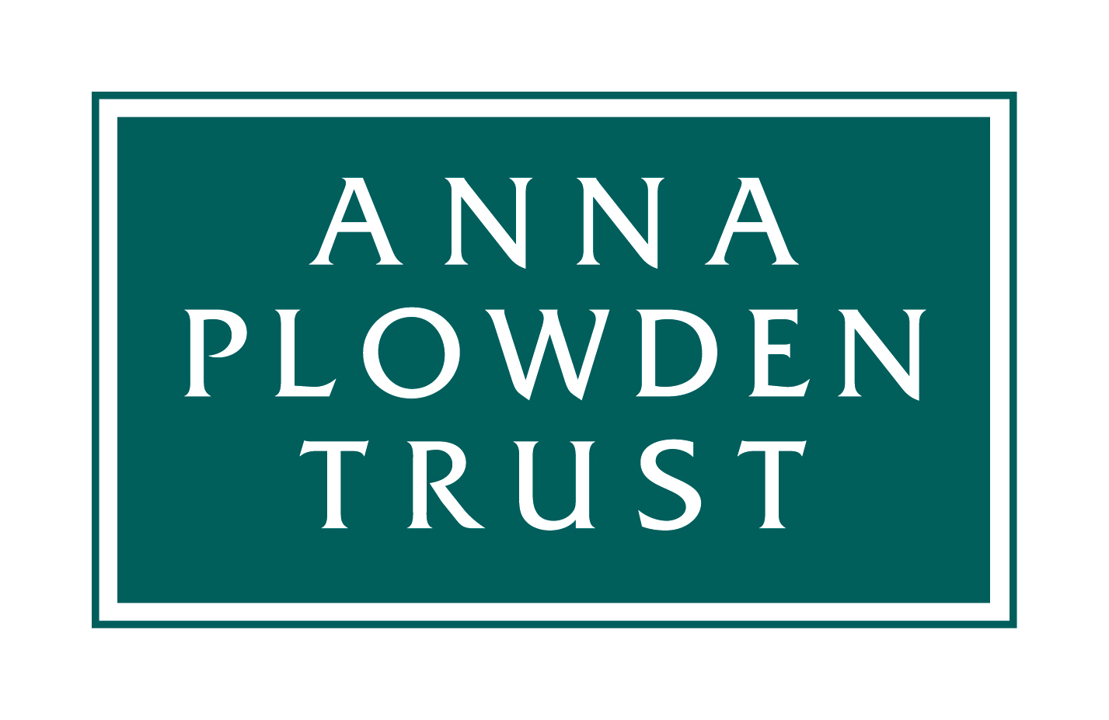
Reg. charity no. 1072236

PLOWDEN SCHOLARSHIP APPLICATION FORM

The deadline for applications is 1st June, 2021

The Trustees of the Anna Plowden Trust offer assistance towards the total cost of attending a full-time conservation training course. Applications will be considered from students who wish to embark on a career in conservation or existing conservators who need to broaden the base of their formal training by attending a course for at least one year. We receive more applications than we can fund, so will normally give preference to applicants who intend to make their career in the UK. Please read our terms and conditions of grant before completing this form.

The Anna Plowden Trust seeks to prevent financial reasons from being an obstacle to entering the conservation sector. The Trust is committed to ensuring its support reaches all underrepresented groups.

Your name:

Contact address:  Home address* (if different from above):  *Some of our funding is from trusts that like to support individuals from certain parts of the country so if you currently live in the town where you are studying but your family home is elsewhere please tell us where that is. | Date of birth:
 | Nationality:
 | E-mail:
 | Tel/Mobile:

Institution to be attended: | Which year will you be in in 2021/22 (1st, 2nd etc)?
Level (e.g. Dip, PG Dip, MA) & Title of course: | Have you a firm offer of a place?
Grant you are requesting from the Anna Plowden Trust for 2021/22  Note that we are only able to support a proportion of the fees and are not able to give grants for living costs | £
1. ABOUT YOU
Please give a summary of your education or training after leaving school, indicating any formal educational qualifications. Also give BRIEF details of previous work experience if relevant. (Maximum 150 words)

MEMBERSHIPS: Please list the conservation organisations of which you are a member (e.g. Icon):

2. FINANCIAL INFORMATION
SUMMARY OF COURSE COSTS
Annual tuition fees | £
Living expenses | £
Travelling expenses | £
Other costs (give details - e.g. books, materials, tools) | £
Estimated total costs for the academic year | £

Sources of funding
To which other funding bodies have you applied? Applicants are encouraged to make a significant effort to raise the funds required. Give details below or list on a separate piece of paper if necessary.

Funder | Amount applied for | Result

Are you or your family in a position to make a contribution? YES/NO
Please give details.

Are you applying for a Career Development/Postgraduate Loan? YES/NO
If your answer is no, please explain why not.

3. CASE FOR SUPPORT
This section gives you the opportunity to put your case to the Trustees. They have many demands on their limited funds, so make clear – briefly and succinctly - why you deserve their support.
What do you hope to gain from the conservation programme? (Maximum 150 words)

Professional plans once you have completed the course (Maximum 150 words)

How would you fund your place on this course if you did not receive a grant from the Anna Plowden Trust?

Why do you feel you merit the support of the Anna Plowden Trust? (Maximum 500 words)

How did you first become aware of the Anna Plowden Trust?

4. DATA PROTECTION DECLARATION
YOU MUST complete this section before submitting your application

I agree that the Anna Plowden Trust may retain relevant personal data (email, postal address, current job) and occasionally send me updates about the Trust’s work, the grants it offers and events it is organising. This agreement is given on the condition that the Trust does not share my data with any other organisation.

Yes No

Your signature: Date:

In signing this application, I confirm that the information that I have given is accurate and that I accept the terms and conditions, listed overleaf, which would apply to any grant that may be awarded to me.

5. REFERENCES
You must submit two references WITH your application.

First reference
The first reference should be from the leader of the conservation course you are planning to attend and should be in support of your application to the Anna Plowden Trust. A letter that simply confirms you have a place on the course is NOT sufficient. Course leaders are aware of this requirement.

Second reference
This might be from your employer (particularly if you have been working in a conservation related role), another tutor or supervisor, or from someone who knows you well and can comment on your suitability for a career in conservation and write in support of your application to the Anna Plowden Trust.

If your referee prefers to send their reference directly they may do so by emailing it AND posting a copy to the address below.

We receive very large numbers of applications and cannot chase missing references - if you fail to ensure that two references are supplied your application will not be considered.

NOW:
1. email your application form AND your references to: info@annaplowdentrust.org.uk

2. ALSO send one hard copy of your application form AND references to the address below:
Penelope Plowden
The Anna Plowden Trust
43 Lansdowne Gardens
London
SW8 2EL

APPLICATIONS AND REFERENCES MUST BE RECEIVED BY 1st June, 2021
______________________

Plowden Scholarships: Grant Conditions
1. The scholarship will be paid to your academic institution and not to your personally. The institution at which you study must email us an invoice at the beginning of the academic year (to info@annaplowdentrust.org.uk).

2. You must send us a report within two months of the end of the academic year (see further details below). In accepting the Scholarship you accept that we may quote from your report for use on our website (www.annaplowdentrust.org.uk) or other publicity material without any further reference to you.

Plowden Scholars: Report Requirements
These should be up to 2,000 words long and contain a brief outline of the course and of your work during the year. Examples of rewarding experiences or of special objects conserved are important, together with analysis of how you found the course and what it has contributed in terms of preparing you for the coming year and/or a future career.

Your report should be accompanied by four or five digital images (in jpeg format, at least 2MB each) of you working on objects. The Anna Plowden Trust may use these images on its website and on social media so please ensure that you have permission to publish them and provide any attributions necessary. Please also provide a caption and credit line for each image. By supplying images you are agreeing that we may use these on our website or in our published annual report.

Your report should be submitted to info@annaplowdentrust.org.uk; if your images are large please send them to that email address using WeTransfer (https://www.wetransfer.com).

Please note: Failure to comply with these conditions will prejudice any future applications from you and may prejudice applications from other students at the same institution.

